Participatory water governance in Honduras
Honduras is the second poorest country in Central America, with approximately 63 percent of the population living below the poverty line. Despite witnessing significant success in the Millennium Development Goal (MDG), the country still has more than one million people who lack access to improved sanitation, and 638,000 people who lack access to safe water. The situation is more challenging for the people living in the rural areas, as many of them obtain their water from small springs that are unprotected, contaminated and often without water during the dry season. Women in these areas often spend up to 6 man-hours to fetch clean water which otherwise could have been used for educational and developmental purposes. Lack of access to clean water also contributes largely to the poverty and poor health of the Hondurans. Diarrhea and hepatitis are some of the illnesses which are rampant in the region.
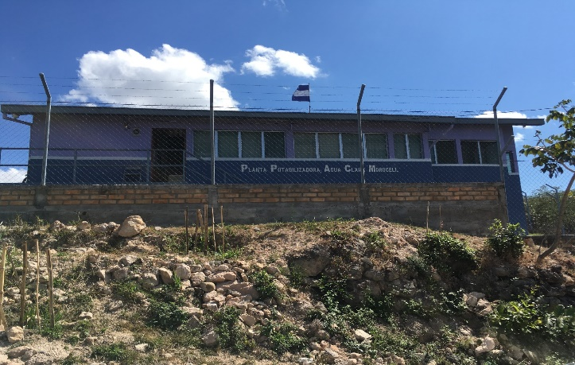
In 2003, the country passed the Water Framework Law which, among many aspects, aimed at reducing poverty through better water resources management. Under this law, SANAA, which is the central water governing body, was required to transfer its service provision functions to the concerned municipalities by 2008 and transform itself into an agency that provides technical assistance to municipalities and juntas (boards).
In 2005, AguaClara, a multi-disciplinary program at Cornell University partnered with Agua Para el Pueblo and commenced the construction of the first community based water treatment plant in Ojojona, Honduras. Since then, 14 plants have been built in various Honduran towns, serving 65,000 people. Majority of these plants are being managed by Juntas de Agua (Water Boards). The Juntas de Agua have played a self-management role. These community-based organizations are considered to be pioneers in provisioning water to most rural and peri-urban areas. The broad constitution of Juntas de Agua is shown below:
Organization Structure of Juntas de Agua
Decentralization of water management has helped in achieving financial sustainability of projects. The municipalities and water boards in discussion with the community have succeeded in achieving increase in water tariff for treated and safe drinking water, reduce operations cost and improve commercial viability of the plants. The water tariff is charged on a flat fee basis ranging from $3 to $5 per month and is sufficient for covering the operation and maintenance costs of the plant. The community based water treatment plant has helped in achieving equity in water distribution, gender equity, improved health, reduction in drudgery of women, generating employment opportunities and saving of money being spent on purchasing bottled drinking water. Apart from being a local water utility service, Juntas de Agua are also engaged in protecting their watershed. They invite students from schools and colleges to come and help them in afforestation.
A community member speaks………
“Previously the water was very dirty. We used to suffer from diarrhea, vomiting and skin infection. I had to travel two hours every day to fetch water. I often suffered from pain in my neck, back and uterus. But, now I am happy. I have the luxury of 24X7 availability of good quality water in my house. Now, I can spend more time with my family.”
-Lillian, Cuatro Comunidades
- Fawzia Tarannum, fawziat@gmail.com

